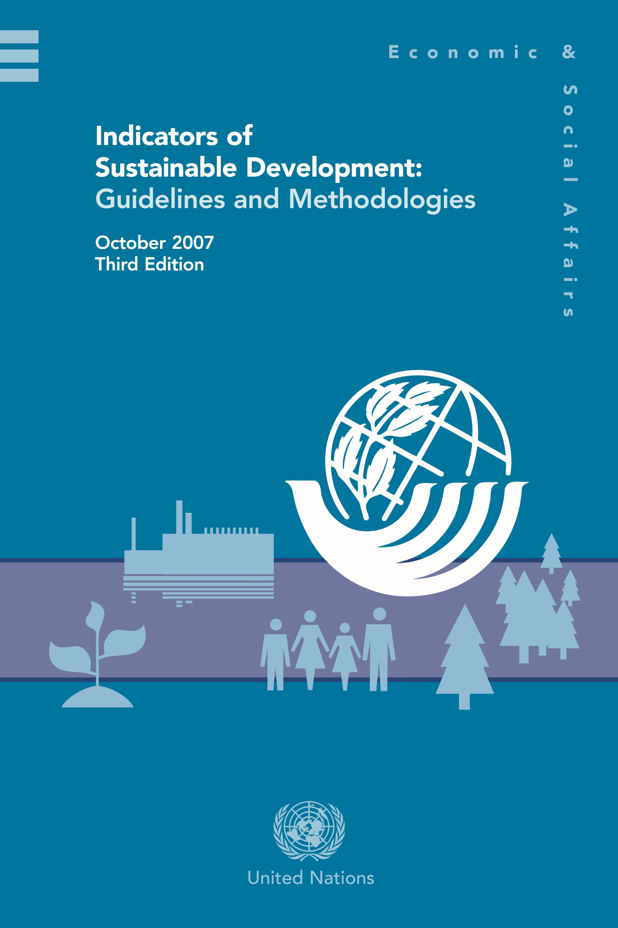

CSD indicator themes
- Poverty  - Governance  - Health  - Education  - Demographics | - Natural hazards  - Atmosphere  - Land  - Oceans, seas and coasts  - Freshwater  - Biodiversity | - Economic development  - Global economic partnership  - Consumption and production patterns

0
The division of indicators along the lines of four ‘pillars’ (social, economic, environmental and institutional) is no longer explicit in the newly revised set. This change emphasizes the multi-dimensional nature of sustainable development and reflects the importance of integrating its pillars. Consequently, new cross-cutting themes such as poverty and natural hazards were introduced and existing cross-cutting themes such as consumption and production patterns are better represented.
Since poverty covers a broad range of related issues, it was conceptually limiting to keep it as a sub-theme under equity. Consequently, it is now a separate theme that includes sub-themes related to income, sanitation, drinking water, energy access and living conditions.
Natural hazards were a sub-theme of the now dissolved theme ‘institutional capacity’, which did not reflect the cross-cutting nature of the topic. Other new themes include global economic partnership and governance. Global economic partnership includes a number of new indicators that capture key issues such as trade and development financing. The indicators for the theme ‘governance’ are largely undeveloped; only crime related indicators are currently included. Significant methodological work is needed to develop good, measurable and internationally accepted indicators on other aspects of governance.

Table 1:

CSD Indicators of Sustainable Development
Theme | Sub-theme | Core indicator | Other indicator
Poverty | Income poverty | Proportion of population living  below national poverty line | Proportion of population below $1 a day
 | Income inequality | Ratio of share in national income of highest to lowest quintile
 | Sanitation | Proportion of population using an improved sanitation  facility
 | Drinking water | Proportion of population using an improved water source

Theme | Sub-theme | Core indicator | Other indicator
Poverty  (continued) | Access to energy | Share of households without electricity or other modern energy services | Percentage of population using  solid fuels for cooking
 | Living conditions | Proportion of urban  population living in  slums
Governance | Corruption | Percentage of population having paid bribes
 | Crime | Number of intentional homicides per 100,000 population
Health | Mortality | Under-five mortality rate
 |  | Life expectancy at birth | Healthy life expectancy at birth
 | Health care delivery | Percent of population with access to primary health care facilities | Contraceptive prevalence rate
 |  | Immunization against infectious childhood diseases
 | Nutritional status | Nutritional status of children
 | Health status and risks | Morbidity of major diseases such as HIV/AIDS, malaria, tuberculosis | Prevalence of tobacco use
 |  |  | Suicide rate
Education | Education level | Gross intake ratio to  last grade of primary education | Life long learning
 |  | Net enrolment rate in primary education
Adult secondary
(tertiary) schooling attainment level
 | Literacy | Adult literacy rate
Demographics | Population | Population growth rate | Total fertility rate
 |  | Dependency ratio
 | Tourism |  | Ratio of local residents to tourists in major tourist regions and destinations
2
Theme | Sub-theme | Core indicator | Other indicator
Natural hazards | Vulnerability to natural hazards | Percentage of population living in hazard prone areas
 | Disaster preparedness and response |  | Human and economic loss due to natural disasters
Atmosphere | Climate change | Carbon dioxide emissions | Emissions of greenhouse gases
 | Ozone layer depletion | Consumption of ozone depleting substances
 | Air quality | Ambient concentration of air pollutants in urban areas
Land | Land use and status |  | Land use change
 |  |  | Land degradation
 | Desertification |  | Land affected by desertification
 | Agriculture | Arable and permanent cropland area | Fertilizer use efficiency
 |  |  | Use of agricultural pesticides
 |  |  | Area under organic farming
 | Forests | Proportion of land area covered by forests | Percent of forest trees damaged by defoliation
Area of forest under
sustainable forest
management
Oceans, seas and coasts | Coastal zone | Percentage of total population living in coastal areas | Bathing water quality
 | Fisheries | Proportion of fish stocks within safe biological limits
 | Marine environment | Proportion of marine area protected | Marine trophic index
 |  |  | Area of coral reef ecosystems and percentage live cover

Theme | Sub-theme | Core indicator | Other indicator
Freshwater | Water quantity | Proportion of total water resources used
 |  | Water use intensity by economic activity
 | Water quality | Presence of faecal coliforms in freshwater | Biochemical oxygen demand in water bodies
 |  |  | Wastewater treatment
Biodiversity | Ecosystem | Proportion of terrestrial area protected, total and by ecological region | Management  effectiveness of protected areas
 |  |  | Area of selected key ecosystems
 |  |  | Fragmentation of habitats
 | Species | Change in threat status of species | Abundance of selected key species
 |  |  | Abundance of invasive alien species
Economic development | Macroeconomic performance | Gross domestic product (GDP) per capita | Gross saving
 |  | Investment share in  GDP | Adjusted net savings as percentage of gross national income (GNI)
 |  |  | Inflation rate
 | Sustainable public finance | Debt to GNI ratio
 | Employment | Employment-  population ratio | Vulnerable employment
 |  | Labor productivity and unit labor costs
 |  | Share of women in wage employment in the non-agricultural sector
 | Information and communication technologies | Internet users per 100 population | Fixed telephone lines per 100 population
 |  |  | Mobile cellular telephone subscribers per 100 population

Theme | Sub-theme | Core indicator | Other indicator
Economic development (continued) | Research and development |  | Gross domestic expenditure on R&D as a percent of GDP
 | Tourism | Tourism contribution to GDP
Global economic partnership | Trade | Current account deficit as percentage of GDP | Share of imports from developing countries and from LDCs
Average tariff barriers imposed on exports from developing countries
and LDCs
 | External financing | Net Official  Development  Assistance (ODA) given or received as a percentage of GNI | Foreign direct investment (FDI) net inflows and net outflows as percentage of GDP
 |  |  | Remittances as percentage of GNI
Consumption and production patterns | Material consumption | Material intensity of the economy | Domestic material consumption
 | Energy use | Annual energy consumption, total and by main user category | Share of renewable energy sources in total energy use
 |  | Intensity of energy use, total and by economic activity
 | Waste generation and management | Generation of hazardous waste | Generation of waste
 |  | Waste treatment and disposal | Management of radioactive waste
 | Transportation | Modal split of passenger transportation | Modal split of freight transport
 |  |  | Energy intensity of transport

Millennium Development Goals
- Eradicate extreme poverty
- Achieve universal primary education
- Promote gender equality and empower women
- Reduce child mortality
- Improve maternal health
- Combat HIV/AIDS, malaria and other diseases
- Ensure environmental sustainability
- Develop a global partnership

